Create a Folder with Linux

**Introduction**

Now you will do the exact same thing that you did for the Windows lab but for the Linux operating system!

**What you’ll do**

There are two learning objectives for this lab:

* Familiarize yourself with the Qwiklabs environment and log into the Google Cloud Console
* Access a Linux VM instance and create a basic file using the command line interface.

**Head's up**

You'll experience a delay as the labs initially load (particularly for Windows labs). So, please **wait a couple of minutes for the labs to load**. Please also make sure to access the labs **directly through Coursera** and not in the Qwiklabs catalog. If you access the labs through the Qwiklabs catalog, you will \*not\* receive a grade. (As you know, a passing grade is required to matriculate through the course.) The grade is calculated when the lab is complete, so be sure to hit "**End Lab**" when you're done!

**You will have 60 minutes to complete this lab.**

Solution:

# **Create a Folder with Linux**

linux-instance external IP address



username



[file\_download](https://googlecoursera.qwiklabs.com/lab_instances/download_pem/15660737" \t "_blank)

[Download PEM](https://googlecoursera.qwiklabs.com/lab_instances/download_pem/15660737" \t "_blank)

[file\_download](https://googlecoursera.qwiklabs.com/lab_instances/download_ppk/15660737" \t "_blank)

[Download PPK](https://googlecoursera.qwiklabs.com/lab_instances/download_ppk/15660737" \t "_blank)

**Introduction**

This lab will introduce you to the Qwiklabs online learning platform. You'll interact with Qwiklabs in lots of courses of the IT Support Professional Certificate program, so it's important that you follow these instructions carefully. We'll give you some background information about what Qwiklabs are, and how these labs will help train you as an IT Support Specialist. Finally, you'll interact with the lab materials themselves. Ready? Let's get started!

**Head's up**: You'll experience a delay as the labs initially load (particularly for Windows labs). So, please **wait a couple of minutes for the labs to load**. Please also make sure to access the labs **directly through Coursera** and not in the Qwiklabs catalog. If you access the labs through the Qwiklabs catalog, you will *not* receive a grade. (As you know, a passing grade is required to matriculate through the course.) The grade is calculated when the lab is complete, so be sure to hit "**End Lab**" when you're done!

What is Qwiklabs?

**Qwiklabs** is an online learning environment that will take you through a live, real-world tech scenario that you may encounter as an IT Support Specialist. Qwiklabs "spin up," or create, virtual machines. A *virtual machine* (VM) is exactly how it sounds: it creates a "virtual" (rather than actual) simulation of software. As you've learned throughout the **Technical Support Fundamentals course**, a Linux operating system (OS) is just a piece of software. This way, you don't have to purchase this software to complete the courses in the IT Support Professional Certificate. This also allows you to use Linux OS as if it was installed on your local machine, so you can practice and familiarize yourself with this technology.

In this Qwiklab, you'll spin up a virtual machine of the Linux OS. In other Qwiklabs throughout the IT Support Professional Certificate, you may spin up other *instances* (or other occurrences) of software; Qwiklabs isn't just limited to operating systems. You'll soon learn that, with Qwiklabs, you can interact with many other real-world scenarios that you may see as an IT Support Specialist.

**Head's up:** Each Qwiklab will create a temporary VM credentials that will last *only* for the duration of the lab. In other words, you'll need to connect VM for each Qwiklab offered in the IT Support Professional Certificate program.

Learning tip:

Whenever possible, we encourage you to try these exercises on your local machines or home computers -- if that's an option for you! When you're learning something new for the first time, or you're trying to improve a skill that you already have, remember that "practice makes perfect." So, practice the skills you'll learn in the Qwiklabs as much as you can!

What you'll do

There are two learning objectives for this lab:

* Familiarize yourself with the Qwiklabs environment.
* Access a Linux virtual machine and create a basic folder using the command line interface.

You'll have 60 minutes to complete this lab.

Start the lab

You'll need to start the lab before you can access the materials in the virtual machine OS. To do this, click the green “Start Lab” button at the top of the screen.

**Note:** For this lab you are going to access the **Linux VM** through your **local SSH Client**, and not use the **Google Console** (**Open GCP Console** button is not available for this lab).

Start Lab

After you click the “Start Lab” button, you will see all the SSH connection details on the left-hand side of your screen. You should have a screen that looks like this:

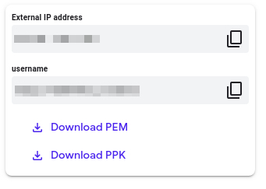

**Accessing the virtual machine**

Please find one of the three relevant options below based on your device's operating system.

**Note:** Working with Qwiklabs may be similar to the work you'd perform as an **IT Support Specialist**; you'll be interfacing with a cutting-edge technology that requires multiple steps to access, and perhaps healthy doses of patience and persistence(!). You'll also be using **SSH** to enter the labs -- a critical skill in IT Support that you’ll be able to practice through the labs.

Option 1: Windows Users: Connecting to your VM

In this section, you will use the PuTTY Secure Shell (SSH) client and your VM’s External IP address to connect.

**Download your PPK key file**

You can download the VM’s private key file in the PuTTY-compatible **PPK** format from the Qwiklabs Start Lab page. Click on **Download PPK**.

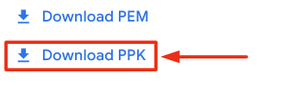

**Connect to your VM using SSH and PuTTY**

1. You can download Putty from [here](https://the.earth.li/~sgtatham/putty/latest/w64/putty.exe)
2. In the **Host Name (or IP address)** box, enter username@external\_ip\_address.

**Note:** Replace **username** and **external\_ip\_address** with values provided in the lab.



1. In the **Category** list, expand **SSH**.
2. Click **Auth** (don’t expand it).
3. In the **Private key file for authentication** box, browse to the PPK file that you downloaded and double-click it.
4. Click on the **Open** button.

**Note:** PPK file is to be imported into PuTTY tool using the Browse option available in it. It should not be opened directly but only to be used in PuTTY.



1. Click **Yes** when prompted to allow a first connection to this remote SSH server. Because you are using a key pair for authentication, you will not be prompted for a password.

**Common issues**

If PuTTY fails to connect to your Linux VM, verify that:

* You entered **<username>**@**<external ip address>** in PuTTY.
* You downloaded the fresh new PPK file for this lab from Qwiklabs.
* You are using the downloaded PPK file in PuTTY.

Option 2: OSX and Linux users: Connecting to your VM via SSH

**Download your VM’s private key file.**

You can download the private key file in PEM format from the Qwiklabs Start Lab page. Click on **Download PEM**.

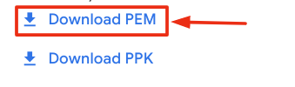

**Connect to the VM using the local Terminal application**

A **terminal** is a program which provides a **text-based interface for typing commands**. Here you will use your terminal as an SSH client to connect with lab provided Linux VM.

1. Open the Terminal application.
   * To open the terminal in Linux use the shortcut key **Ctrl+Alt+t**.
   * To open terminal in **Mac** (OSX) enter **cmd + space** and search for **terminal**.
2. Enter the following commands.

**Note:** Substitute the **path/filename for the PEM** file you downloaded, **username** and **External IP Address**.

You will most likely find the PEM file in **Downloads**. If you have not changed the download settings of your system, then the path of the PEM key will be **~/Downloads/qwikLABS-XXXXX.pem**

chmod 600 ~/Downloads/qwikLABS-XXXXX.pem

ssh -i ~/Downloads/qwikLABS-XXXXX.pem username@External Ip Address

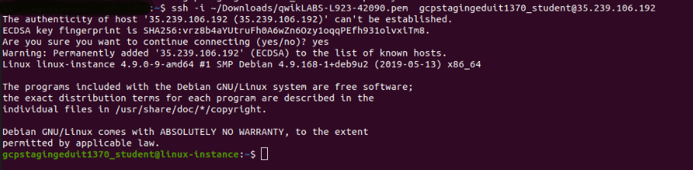

Option 3: Chrome OS users: Connecting to your VM via SSH

**Note:** Make sure you are not in **Incognito/Private mode** while launching the application.

**Download your VM’s private key file.**

You can download the private key file in PEM format from the Qwiklabs Start Lab page. Click on **Download PEM**.



**Connect to your VM**

1. Add Secure Shell from [here](https://chrome.google.com/webstore/detail/secure-shell-app/pnhechapfaindjhompbnflcldabbghjo) to your Chrome browser.
2. Open the Secure Shell app and click on **[New Connection]**.

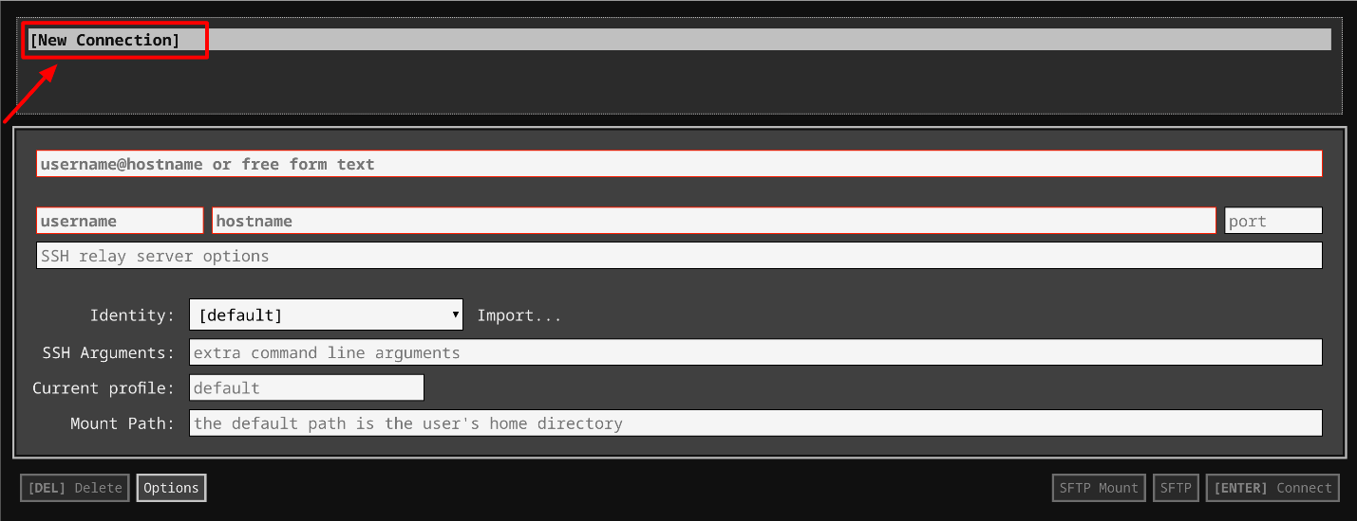

1. In the **username** section, enter the username given in the Connection Details Panel of the lab. And for the **hostname** section, enter the external IP of your VM instance that is mentioned in the Connection Details Panel of the lab.

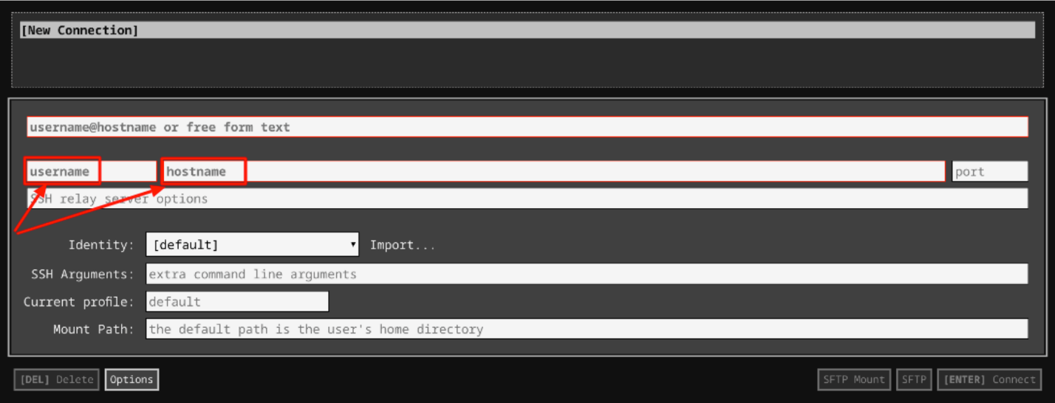

1. In the **Identity** section, import the downloaded PEM key by clicking on the **Import…** button beside the field. Choose your PEM key and click on the **OPEN** button.

**Note:** If the key is still not available after importing it, refresh the application, and select it from the **Identity** drop-down menu.

1. Once your key is uploaded, click on the **[ENTER] Connect** button below.

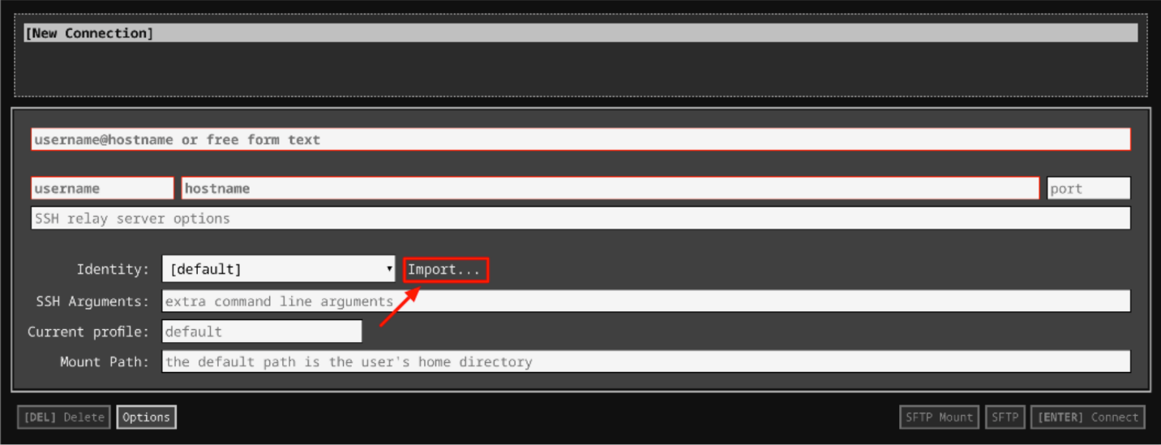

1. For any prompts, type **yes** to continue.
2. You have now successfully connected to your Linux VM.

You're now ready to continue with the lab!

**Creating a Folder**

To create a sample folder, enter this command into the terminal:

mkdir my-super-cool-folder

This creates a directory called "my-super-cool-folder" in your current directory.

Click *Check my progress* to verify the objective.